let me ask you the best way for me to work with you and how to break up things as we get more into the system... it is definitely getting big... so we have these systems: dashboard/ui, member portal <web access>, benevolence fund, dispatch/referral, member info (& associate member), reports, import/export/scanning/document management, dues, pre-apprenticeship, SALTing, Employer info, logging,.... how do we focus on just a couple of things at a time not to overwhelm your systems.
- Seperate projects? and update instructions under each one to keep contunity?
- what say you?
6:55 PM
Architected modular project structure balancing context limits and continuity
This is exactly the right question to be asking right now, and honestly, the fact that you're asking it tells me you've got good instincts. Let me pull up what we've been working with to give you the most informed answer.
Architected strategic project grouping to balance context limits and development workflow
Alright Xerxes, I've done a deep sweep across all your project threads. Good question, and the timing is perfect because you're at exactly the inflection point where this needs to be addressed before it becomes a problem rather than after.
Let me walk you through my thinking.

The Problem You're Actually Solving
It's not just "how do I organize conversations" — it's really three problems:
- Context window saturation — every conversation has a finite brain. When you paste in a 600-line continuity doc plus upload 5 PDFs plus have a complex discussion, we're burning through context fast and the quality of work degrades toward the end.
- Instruction bloat — if you try to put every module's rules, conventions, schema details, and business logic into one project's instructions, the instructions alone eat a quarter of the context before you even say hello.
- Cognitive load on you — you're working 5-10 hours a week. If you have to remember which of 12 projects to open for a given question, you've created a management overhead problem that steals time from building.
What I'd Recommend: A Hub-and-Spoke Model
Not one project per module. Not everything in one project. A strategic grouping that mirrors how the data and workflows actually relate to each other.
The Hub (This Project — Keep It)
Purpose: Strategic planning, architecture decisions, cross-cutting concerns, roadmap management, documentation updates.
What lives here: ADR discussions, schema debates, deployment planning, stakeholder strategy, roadmap reviews, and conversations exactly like this one where you're figuring out how to approach something before you build it.
What does NOT live here: Actual code production, module-specific implementation details, file uploads for analysis.
This project's instructions stay lean — project overview, governance philosophy, tech stack summary, and pointers to where detailed work happens. Think of it as your docs_README.md in project form.
Spoke 1: Core Platform — Members, Dues, Employers
Modules covered:
- Member Info (& associate members)
- Dues
- Employer Info
- Member Portal (web access)
Why these group together: They're all anchored to the members table. Dues are member transactions. Employers are where members work. The member portal is the member-facing view of all of this. When you change something about how members are stored, it ripples through all four. You want those conversations in the same context so Claude can flag conflicts.
Project instructions would include: Member schema details, dues business rules, RBAC for member data, portal access patterns, QuickBooks sync rules.
Spoke 2: Operations — Dispatch, Programs, Organizing
Modules covered:
- Dispatch/Referral (your big Phase 7)
- Pre-Apprenticeship (IP2A program)
- SALTing (organizing campaigns)
- Benevolence Fund
Why these group together: These are operational workflows that consume member data but have their own complex business logic. The dispatch system alone has 14 business rules, 11 book tiers, and a 12-table schema. Pre-apprenticeship has cohorts, training records, and grant reporting. These need room to breathe without competing with member schema discussions for context space.
Project instructions would include: LaborPower findings, referral procedures business rules, book catalog, APN encoding rules, pre-apprenticeship entities, grant compliance requirements.
Spoke 3: Infrastructure — UI, Reports, Documents, Logging
Modules covered:
- Dashboard/UI (the Jinja2+HTMX frontend layer)
- Reports
- Import/Export/Scanning/Document Management
- Logging (Grafana+Loki operational, PostgreSQL audit)
Why these group together: These are cross-cutting services that serve every other module. The dashboard renders data from Core and Operations. Reports pull from everywhere. Document management attaches files to any entity. Logging watches everything. They share a common concern: "how do we present, move, and monitor data across the whole system?"
Project instructions would include: Frontend conventions (Jinja2, HTMX, Alpine.js, DaisyUI patterns), component library standards, file storage architecture (MinIO/S3), report templates, logging tiers (audit vs. operational).

How the Pieces Stay Connected
Here's where most people go wrong with splitting things up — they create silos and then can't remember what they decided in the other project. Here's how you prevent that:
The docs_README.md is your ground truth. You've already built this — it's the navigation layer that points to every document in the project. When you make a decision in the Hub that affects a Spoke, you update the README and the relevant Spoke's instructions.
Continuity documents bridge projects, not conversations. You've been using continuity docs to bridge between chat threads within a project. Same principle applies between projects. When your Dispatch work surfaces a schema change that affects how members are stored, you generate a brief continuity note and bring it into the Core Platform project.
Project instructions stay lean and focused. Each Spoke gets instructions specific to its domain. Not a copy of the entire roadmap — just the rules, conventions, and context that Claude needs to work effectively in that domain. Think of it like giving a new developer a focused onboarding doc for their team, not the company's entire wiki.
Memory handles the glue. Claude's memory system picks up patterns across all your projects. Things like your governance philosophy, your naming conventions, your tech stack — those persist without you having to repeat them.
What This Looks Like In Practice
Monday evening, you have 2 hours. Here's how it flows:
You open Hub → "I need to think through how check marks and penalties should work in the dispatch schema." We hash it out, produce a decision and maybe an ADR draft. You grab the key conclusions.
Next week, you open Spoke 2 (Operations) → paste in the decision, upload LaborPower CSVs → "Build me the schema corrections we discussed and create the implementation instructions for Claude Code." Focused work, no noise from the UI framework or dues rules eating context.
Following week, you open Spoke 3 (Infrastructure) → "I need the dispatch dashboard screen. Here's the schema from Operations." Build the frontend components that render dispatch data.
Each session is focused. Each project's Claude instance knows its domain deeply rather than knowing everything shallowly.
The Migration
You don't need to do this all at once. Here's the practical path:
- Keep this project as the Hub — it already is. Update the instructions to reflect that it's the strategic planning layer.
- Create Spoke 2 (Operations) first — this is where your active Phase 7 work lives. The LaborPower analysis, referral schema, dispatch business rules. That's the most context-heavy work right now and benefits the most from isolation.
- Create Spokes 1 and 3 when you need them — you're not actively building member management or the report engine right now. Don't create empty projects. Create them when you have work to do in that domain.
- For each Spoke, write focused instructions — I can help you draft these. They should be 200-400 lines max — enough to orient Claude in 30 seconds, not enough to burn half the context window.

One last thing I want to flag: the instinct to create a project per module (12 projects) feels organized but it's actually a management nightmare for a solo part-time developer. You'd spend more time figuring out which project to open than actually building. Four projects is the sweet spot — focused enough to keep context clean, few enough that you always know where to go. And you can always split a Spoke later if one domain gets truly massive, but I'd bet money you won't need to before v1.0.
What do you think? Want me to draft the instructions for the Operations Spoke so you can see what a focused project setup looks like?
yes, but i forgot once very important component, security... where would that fit?
7:02 PM
Architected security as cross-cutting hub governance with distributed implementation
Good catch, and the fact that you're calling it out separately tells me you understand something that a lot of people miss — security is not a feature you bolt on at the end. It's a discipline that runs through everything. So let's talk about where it actually lives, because the answer isn't as simple as "Spoke 4."
Why Security Doesn't Get Its Own Spoke
My first instinct might be to say "give it its own project," but I'd actually argue against that for your situation, and here's why:
Security is a cross-cutting concern, not a vertical domain. Dispatch has its own tables, its own business rules, its own screens. Members have their own schema, their own CRUD operations. Security doesn't work that way — it's the rules about who can touch all of those things and how we prove it later. If you isolate security discussions into their own project, you create a dangerous gap where you're making schema decisions in Spoke 2 without the security context in front of you, and making security decisions in Spoke 4 without the operational business rules in front of you.
That's how you end up with a beautifully architected RBAC system that doesn't actually map to how dispatchers need to work. I've seen it happen.
Where Security Actually Lives — Three Layers
Think of it like building codes for a physical building. The code doesn't live in one room — it governs the foundation, the wiring, the plumbing, and the fire exits. But the authority that sets and enforces those codes sits at a specific level.
Layer 1: Security Governance → The Hub (This Project)
This is where security policy and architecture decisions get made. You've already started this — ADR-001 (authentication strategy), ADR-008 (two-tier logging), the RBAC role matrix, the 7-year NLRA compliance requirement. These are constitutional-level decisions that don't belong to any one module.
The Hub's project instructions get a dedicated security section covering:
- Authentication architecture (JWT + bcrypt, token lifecycle, refresh strategy)
- Authorization model (role hierarchy: Admin → Officer → Staff → Organizer → Instructor → Member → Steward → Applicant)
- Audit policy (what gets logged, retention periods, immutability rules)
- Data classification (what's PII, what's sensitive, what's public)
- Compliance requirements (NLRA 7-year retention, any state-specific rules)
- Network security posture (Caddy headers, HTTPS, CORS policy)
- The "never" list (never store passwords in plaintext, never log PII in operational logs, never trust client-side role claims, etc.)
When you need to debate a security question — "should stewards be able to see dispatch history for members in their shop?" — that's a Hub conversation because it's a policy decision that affects multiple modules.
Layer 2: Security Implementation → Spoke 3 (Infrastructure)
The middleware, the decorators, the JWT validation logic, the audit triggers, the Caddy configuration, the Grafana dashboards that monitor for suspicious patterns — all of that is infrastructure that serves every module. It lives in Spoke 3 because that's where cross-cutting implementation lives.
When you're building the actual @require_role("dispatcher") decorator, or writing the audit trigger that fires on every UPDATE to the members table, or configuring rate limiting on the API — that's Spoke 3 work.
Layer 3: Security Rules Per Domain → Each Spoke's Instructions
This is the part most people forget. Each Spoke needs a concise security section in its instructions that captures the access rules specific to that domain. For example:
Spoke 1 (Core Platform) instructions would include:
- Members can view their own record, not others'
- Stewards can view members in their assigned shop only
- Staff can view all members but only Admin can edit sensitive fields (SSN, DOB)
- Dues payment history is visible to the member and Staff+
- QuickBooks sync credentials are Admin-only
Spoke 2 (Operations) instructions would include:
- Dispatch registration is member-self-service (they sign their own books)
- Dispatchers (Staff role) can modify registrations and process referrals
- The check mark penalty system can only be applied by Staff+, never self-service
- SALTing campaign data is restricted to Organizer+ (members should never see organizing targets)
- Pre-apprenticeship student records have FERPA-adjacent sensitivity
Spoke 3 (Infrastructure) instructions would include:
- Audit logs are immutable — no UPDATE or DELETE, ever
- Operational logs (Loki) must redact PII before ingestion
- File uploads get virus-scanned before storage
- Report generation respects the requesting user's role — a Member running a report sees different data than an Admin running the same report

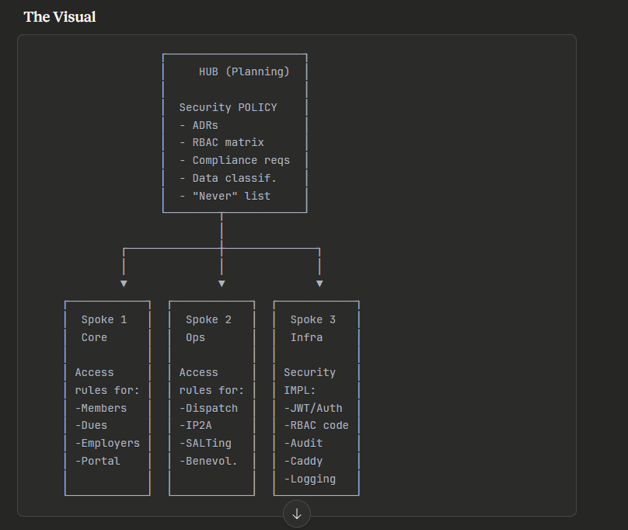
Why This Works Better Than a Separate Security Project
When you're in Spoke 2 building the dispatch schema and you need to add created_by, modified_by, and audit_trigger to every table — the security rules are right there in the Spoke's instructions. You don't have to context-switch to a different project to remember "oh right, every table that touches member data needs audit columns."
When you need to make a new security policy decision — "can traveling members from other locals see our book standings?" — you take that to the Hub where you can think about it architecturally without getting bogged down in implementation details.
When you need to implement a new piece of security infrastructure — say, adding API rate limiting — you do that in Spoke 3 where all the middleware and cross-cutting services live.
The security concern flows through the system the same way it flows through the code. It's not siloed — it's woven in.

So the updated model stays at four projects, but the Hub gets a beefier security governance section, and each Spoke gets explicit security context in its instructions. Want me to start drafting those instructions now, beginning with the Operations Spoke since that's your active work? I'll make sure the security layer is baked in from the start rather than tacked on as an afterthought.

